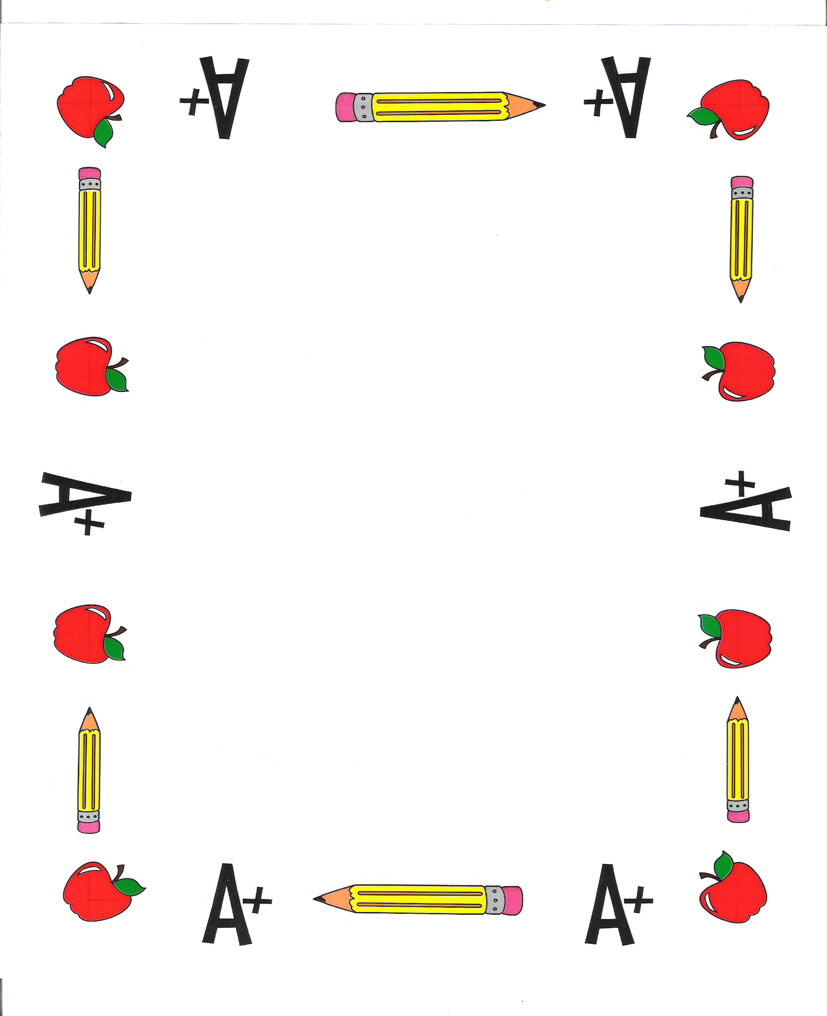
SPSEA Kickoff Meeting Minutes
September 9th, 2022
@ 11:50am in Hempfield Room

Welcome! So happy to see you all again!

- Introduction of Officers and Professors:
- Ice Breaker:
- Calendar/Co-Chairs Available:

Upcoming Events:
- Chairperson Meeting
  - September 14th
  - 12:00pm in Powers Hall 114
  - ALL Chairpersons should try to attend
- MANDATORY Freshman Meeting
  - September 28th
  - 11:50-12:55 in the Hempfield Room
  - ALL FRESHMEN are REQUIRED to attend
- MANDATORY Sophomore Meeting
  - September 29th
  - 11:50-12:55 in the Hempfield Room
  - ALL SOPHOMORES are REQUIRED to attend
- Superintendents Speaker & Share Workshop
  - September 12th
  - 5:30 in Hempfield Room
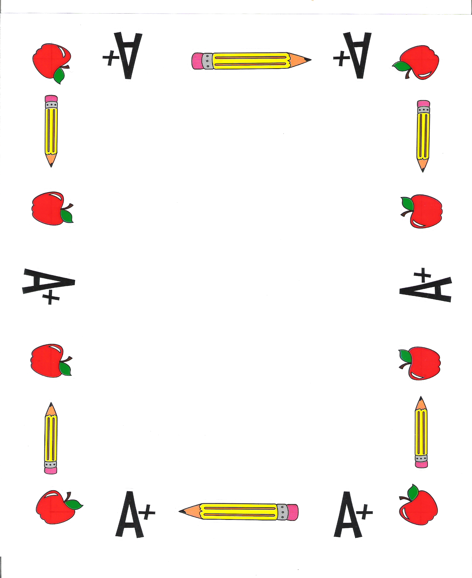
Looking Forward to:
- Open CO-CHAIR positions
  - Please email one of us if you are interested!
- Fundraising
- DC/Gettysburg Trip
  - Email one of us for more information
  - Get forms from Dr. Marks office
- Blue and Gold
  - Please email one of us if you are interested!
- Hallowboo

Advisor Report?

Next Meeting is:
- September 21st at 12 in Powers Hall 114

Any questions, comments, or suggestions??

Officer Contacts
Amber Bloom  724-600-5942  Ajb290@pitt.edu | Emily Gill  267-401-8944  Egp16@pitt.edu | Emma Winkie  724-420-2620  Eew53@pitt.edu | Brennen Marsh  724-487-8825  Brm220@pitt.edu

